Ian Brand Nursing Home

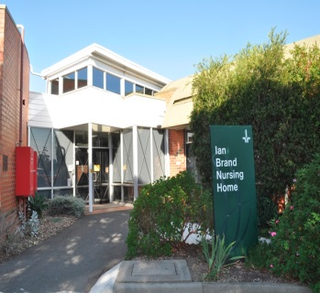

The Ian Brand Nursing Home is a fully accredited facility located on site of Bundoora Campus of Northern Health.
Our service is focussed on providing the best possible care to you and your family and this is achieved by having all our clinical staff be registered nurses.
We have been providing care to our community for over twenty years.

Please feel free to contact us and see our facility features, this includes;
- Single rooms with shared bathroom
- Large garden areas and pathways
- Room for private family functions
- Close links to Northern Health Medical and Allied Health staff such as Physiotherapy, wound nurses and Podiatry
- Well established General Practitioners
- Other services include visiting hairdresser, Wifi (bring your own device), Pet Therapy, Pastoral Care and other wellness and lifestyle activities
- Strong resident’s council
- Located on Tram line 86 – Tram stop 64.

Accommodation:
Thirty (30) single rooms without ensuites (Maximum occupancy is one person per room).

Fees
All our fee information is listed on My Aged Care. The Refundable Accommodation Deposit (RAD) is set at $350,000. Combination payments of Refundable Accommodation Deposits (RAD) and Daily Accommodation Payments (DAP) are able to be negotiated if required.

Some assistance is provided for parking permits are available for each resident’s family.

Contact us for a tour or further information:

Address: 1231 Plenty Road Bundoora 3083: Melways reference 19 J1
Phone: (03) 9495 3188 Fax (03) 9495 3200
Email: Manager Donna.James@nh.org.au

