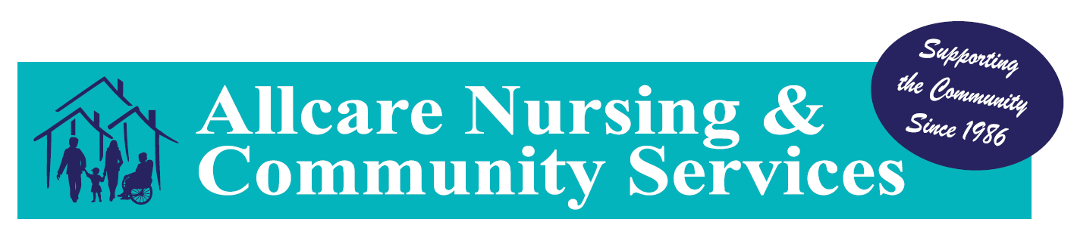
AGED CARE PACKAGES AND FEE SCHEDULE
As of 1st July 2025 PUBLIC
CLINICIANS (Minimum 1 hour) | RATE
MONDAY TO FRIDAY 6AM – 6PM | $175.25 P/Hour
MONDAY TO FRIDAY 6PM – 6AM (Non-Standard Hours) | $261.35 P/Hour
SATURDAY | $261.35 P/Hour
SUNDAY | $348.50 P/Hour
PUBLIC HOLIDAYS | $436.95 P/Hour
SUPPORT SERVICES -  Respite, Personal Care, Social Support, Shopping, Household Tasks | RATE
MONDAY TO FRIDAY 6AM – 6PM | $89.20 P/Hour
MONDAY TO FRIDAY 6PM – 6AM (Non-Standard Hours) | $134.05 P/Hour
SATURDAY | $134.05 P/Hour
SUNDAY | $178.30 P/Hour
PUBLIC HOLIDAY | $223.20 P/Hour
Lawns and Gardening | $100.00 P/Hour
DOMESTIC ASSISTANCE | RATE
MONDAY TO FRIDAY 6AM – 6PM | $89.20 P/Hour
MONDAY TO FRIDAY 6PM – 6AM | $134.05 P/Hour
SATURDAY | $134.05 P/Hour
SUNDAY | $178.30 P/Hour
PUBLIC HOLIDAY | $223.20 P/Hour

PUBLIC
MISCELLANEOUS COSTS |  |  | RATE
KILOMETER ALLOWANCE |  |  | $1.65 per Kilometre
OVERNITE RESPITE WEEKDAYS (10pm-6am) |  |  | $429.00
OVERNITE RESPITE SATURDAY (10pm-6am) |  |  | $504.00
OVERNITE RESPITE SUNDAY (10pm-6am) |  |  | $529.00
OVERNITE RESPITE PUBLIC HOLIDAY (10pm-6am) |  |  | $646.05
CARE MANAGEMENT AND PACKAGE MANAGEMENT COST
Fully Managed by Provider
CARE MANAGEMENT – Per Fortnight | PACKAGE MANAGEMENT – Per Fortnight
LEVEL ONE - $72.47 | LEVEL ONE - $46.09
LEVEL TWO - $127.48 | LEVEL TWO - $97.47
LEVEL THREE - $277.39 | LEVEL THREE - $212.12
LEVEL FOUR - $420.54 | LEVEL FOUR - $321.64
BASIC DAILY FEE | $0.00
EXIT FEE | $0.00
INCOME TESTED FEE – IF YOU RECEIVE A PART-PENSION OR YOU ARE A SELF-FUNDED RETIREE, YOU MAY NEED TO PAY AN INCOME-TESTED FEE WHICH WILL BE DETERMINED BY A FORMAL INCOME ASSESSMENT BY SERVICES AUSTRALIA.
ADDITIONAL COSTS (OPTIONAL) |  | RATE
CLINICAL CONSULTATION |  | $268.00 P/Hour
NURSING TELEHEALTH CONSULT |  | $105.00 P/Hour

