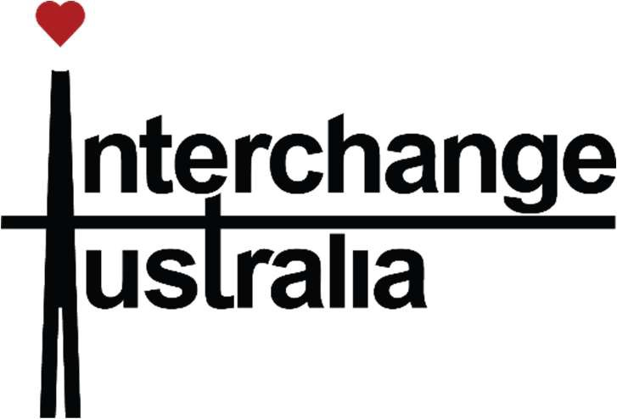
HOME CARE PACKAGE PRICING LIST

Service Charges (per hour)
3 Forest Lane Bowral NSW 2576
PO Box 1284 Bowral NSW 2576
Phone: 02 4868 6688
Email: info@interchangeau.org Website: www.interchangeau.org

 | Mon-Fri 6am – 8pm | Mon to Fri 8pm - 6am | Saturday 24 hours | Sunday 24 hours | Public Holidays  24 hours
Care Staﬀ per hour (non-clinical) | $76.00 | $82.00 | $99.00 | $130.00 | $165.00
Care Staﬀ per hour  (clinical) | $136.00 | NA | NA | NA | NA

Care & Package Management Charges

Home Care Package Level | Daily max. Care & Package  Management Charge | Fortnightly max. Care & Package  Management Charge
Level 1 | $ 7.14 | $ 99.96
Level 2 | $ 12.55 | $175.70
Level 3 | $ 26.24 | $367.36
Level 4 | $ 39.10 | $547.40
**For transparency purposes further breakdown of individual package and care management charges are outlined below)

OTHER CHARGES
Travel charge: $1.20 per km, if required within the service.
Length of service: as agreed upon with service consultant e.g. 45mins – 2 hrs Basic Daily Care Fee: Not charged by Interchange Australia
Income Tested Fee: Calculated by Services Australia https://www.myagedcare.gov.au/home-care- package-costs-and-fees#income-tested-fee

**Individual breakdown of Package Management Charges

Home Care Package Level | Daily max. Package Management Charge | Fortnightly max. Package Management Charge
Level 1 | $2.66 | $37.24
Level 2 | $4.64 | $64.96
Level 3 | $10.12 | $141.68
Level 4 | $15.21 | $212.94

**Individual breakdown of Care Management Charges

Home Care Package Level | Daily max. Package Management  Charge | Fortnightly max. Package  Management Charge
Level 1 | $4.48 | $62.72
Level 2 | $7.91 | $110.74
Level 3 | $16.12 | $225.68
Level 4 | $23.89 | $334.46

