This schedule provides information on the price for common services you can access through your Support at Home Package. There are many other services you can access through a Support at Home Package that are not listed in this schedule. This may include allied health services and aids or equipment which may form part of your support plan. Services delivered as part of your support plan are GST-free. Manjimup Home and Community Care will provide you with other prices if required.
Approximate HCP care recipient Amount |  | Transitioned HCP Level 1 | Transitioned HCP Level 2 | Transitioned HCP Level 3 | Transitioned HCP Level 4
Support at Home Funding | Annual | $10,986.50 | $19,319.45 | $42,055.30 | $63,758.20
Support at Home Funding | Per Quarter | $2,471.96 | $4,346.88 | $9,461.44 | $14,345.30
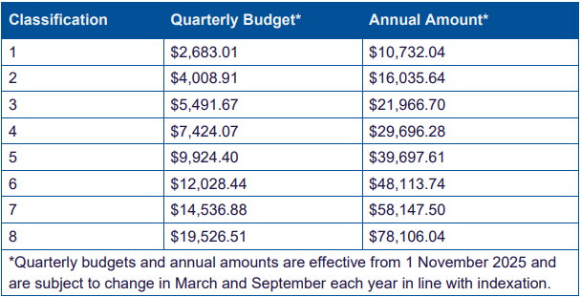

Please Note: You may be required to make a contribution to the cost of your care by paying a co-contribution fee, depending on your pensioner status, as determined by Services Australia. The Support at Home Package funding amounts are current as at 01/07/2025. Further information about your contributions can be found on My Aged Care.

Care Management
Care management is an important service that includes coordination care and services that will help us and you deliver on the goals you identified in your support plan. Every Home Care Package including those being Self-Managed will require some level of care management.

 |  | Level 1 | Level 2 | Level 3 | Level 4
Fully managed by Provider | Per Fortnight | $50.98 | $79.64 | $155.94 | $228.74
Fully managed by Provider | Approx no. hours per fortnight | .5 | 1 | 2 | 3
Self-managed by you | Per Fortnight | $50.98 | $79.64 | $155.94 | $228.74
Self-managed by you | Approx no. hours per fortnight | .5 | 1 | 2 | 3

Maximum Exit Fee | Max. Total | $0
Transport Costs
  Independence-Direct Transport (One Way) 1-5 kms | $7.50
  Independence-Direct Transport (One Way) 6-10km | $15.00
  Independence-Direct Transport (One Way) 11-30km | $25.00
  Independence-Direct Transport (One Way) 31-60km | $50.00
  Independence-Direct Transport (One Way) 61-99km | $75.00
  Independence-Direct Transport (One Way) Bunbury | $150.00
  Independence-Direct Transport (One Way) Busselton | $150.00

Price for common services | How the provider delivers services | Standard hours | Non-standard hours | Saturday | Sunday | Public Holiday
Personal Care  (per hour) | By the provider employee | $100.00 | $144.00 | $144.00 | $193.50 | $193.50
Enrolled Nurse (per hour) | By the provider employee | $140.00
Registered Nurse (per hour) | By the provider employee | $160.00 |  | $240.00 | $320.00 | $320.00
Cleaning and household tasks (per hour) | By the provider employee | $95.00 | N/A | N/A | N/A | N/A
Light Gardening  (per hour) | By the provider employee | $103.00 | N/A | N/A | N/A | N/A
In-home respite (per hour) | By the provider employee | $99.00 | $148.50 | $148.50 | $198.00 | $198.00
Social Support (Individual) | By the provider employee | $99.00 | $148.50 | $148.50 | $148.50 | $148.50
Price for common services | How the provider delivers services | Standard hours | Non-standard hours | Saturday | Sunday | Public Holiday
Social Support (Group) | By the provider employee | $50.00 (includes transport and meal) | N/A | $40.00 | N/A | N/A
Meals on wheels | By the provider employee | 3 x course = $21.50  2 x course = $19.00 | N/A | N/A | N/A | N/A

