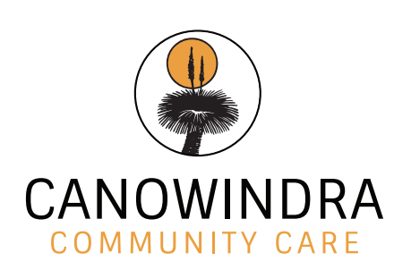

SUPPORT AT HOME SERVICE PRICE GUIDE
1 November 2025
Support at Home Services

- We provide a wide range of Support at Home services designed to meet your unique requirements.
- We are a local community based and controlled organisation
- We have been an approved provider for 20 years
- We support you to continue to remain living at home for as long as possible
- We aim for our fees to be competitive while still providing you with a quality service.

Direct Care & Services

Including but not limited to services such as domestic assistance, personal care, social support, transport, shopping, respite in your home, meal preparation and light gardening.

Days | 45 min or less | 1 hour
Monday – Friday: 7.00am – 4.30pm | $75 | $100
Saturday | $112.50 | $150
Sunday | $150 | $200
Public holidays | $187.50 | $250

Clinical Care & Services

Including nursing care, allied health and other therapeutic services, nutrition and care management provided by our brokered Registered Nursing team.

Days | 45 min or less | 1 hour
Monday – Friday: 7.00am – 4.30pm | $112.50 | $150
Saturday | $168.75 | $225
Sunday | $225 | $300
Public holidays | $280 | $375

Brokerage Services & Subcontractors

To meet your needs, we may engage a third-party organisation to deliver your direct care and services.
Third-party fees and costs will be clearly documented in your care plan.

Social Group

Ladies and Men’s groups that provide social interaction and involvement in community life through group-based activities and outings.

Per participant without transport | 2 hours | $85
Per participant with transport | 2 hours | $100
Provide Transport Assistance | - | POA

Care Management Costs

10% will be allocated for the coordination of care and services per classification each quarter.

1 | 2 | 3 | 4 | 5 | 6 | 7 | 8
$275 | $400 | $550 | $750 | $1000 | $1200 | $1450 | $1950

Travel costs

We can take you to medical and other appointments, shopping, social outings

Transport | $1.50 per km

Cedric House Respite Cottage

All meals are covered and 24/7 Care is provided for short term low care respite

 | Monday – Friday | Saturday | Sunday | Public Holiday | Monday - Sunday
Daily rate | $65.00 | $97.50 | $130.00 | $162.50 | -
Weekly rate | - | - | - | - | $455.00

Canowindra Community Care has been established and serving the Tweed Heads Ageing community since 1991. We provide services to all members of the community and specialise in providing a culturally appropriate service to our Indigenous community.

Contact us
Canowindra Community Care
Unit 16/21 Enterprise Avenue
Tweed Heads South NSW 2486
T: 07-55-230-311 E: ablagecare@bigpond.com M: 0414291259

We acknowledge the Traditional Custodians of the land where we live and work and their continuing connection to land, water, sea and community. We pay respects to Australia's First Peoples, to their unique and diverse cultures, and to Elders past, present and future.

