

Vivian Bullwinkel Lodge

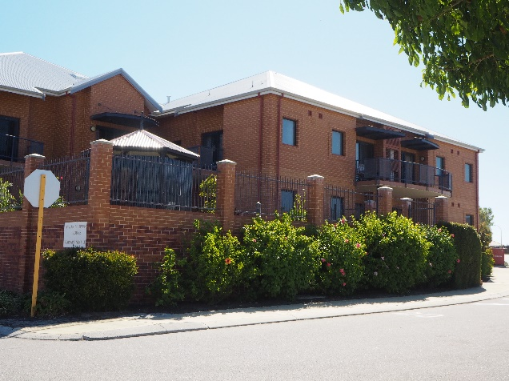

Welcome to our Home

Vivien Bullwinkel Lodge is a 79 bed, Residential Care Centre located in the heart of Cambrai Village, Merriwa. The Lodge offers permanent, respite and dementia care.

The Lodge has generous size bedrooms with ensuites over 2 levels serviced by a lift. Bedrooms on level one have access to private or shared balconies, many of which have uninterrupted views to surrounding suburbs and parklands. There is easy access to outdoor gardens and pathways.

All rooms have reverse cycle air- conditioning. Common areas are well appointed with kitchenette facilities and flat screen TV's. Small internal courtyards and beautifully manicured gardens make pleasant outdoor areas for residents and loved ones to enjoy.

Your accommodation
- Ensuite bathroom
- Adjustable bed
- Air Conditioning
- Many rooms have direct access to courtyards
- Curtains for maximum privacy
- Built in robes
- Bedside cabinets

Experience at Vivian Bullwinkel Lodge

Like all RAAFA Residential Care Centres, Vivian Bullwinkel Lodge has a wide range of amenities available for our residents including:

- Individualised care, complimented by hotel services
- 7 days a week, 24 hours a day nurse support
- A comprehensive activities program
- Separate dining areas with Chef prepared meals offering a variety of summer and winter menu choices
- Homely, comfortable and well-appointed lounge areas
- Large central activity room
- Attractive gardens and courtyards
- Hairdressing salon
- Multi-faith chapel
- Telephones in rooms and Wi-Fi available throughout the facility
- Library
- On site allied and medical health services including GP, podiatry, physiotherapy and occupational therapy
- Internal atriums with attractive water features off dining rooms and internal passageways create a calming atmosphere

There are a range of rooms available starting from a Refundable Accommodation Deposit (RAD) of $250,000 to $500,000.

T: (08) 9206 6000
F: (08) 9206 6160
E: vivian@raafawa.org.au
W: www.raafawa.org.au

Virtual tours available on website

Cambrai Village
85 Hester Avenue
Merriwa WA 6030

