Sunday星期日  July 2015 | Monday星期一 | Tuesday星期二  印 支 高 齡 宿 舍  Indo-Chinese Elderly Hostel | Wednesday星期三 | Thursday星期四 | Friday星期五  2015 年7 月 | Saturday星期六
《梅花》  【宋】王安石  牆角數枝梅,  凌寒獨自開。  遙知不是雪,  為有暗香來。 | 《江雪》  【唐】柳宗元  千山鳥飛絕，  萬徑人踪滅。  孤舟蓑笠翁，  獨釣寒江雪。 | 《終南望余雪》  【唐】祖詠  終南陰嶺秀，  積雪浮雲端。  林表明霽色，  城中增暮寒。 | Gentle exercise 1  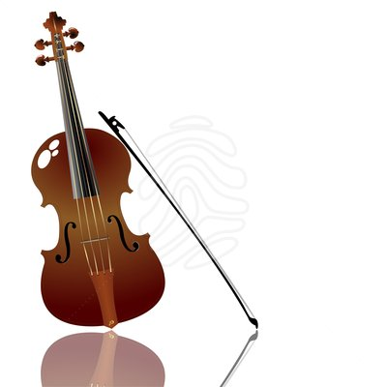  Newspaper reading  Violin performance  Watch TVBJ/movie  Game/karaoke  輕柔運動/閱讀報纸  小提琴表演  看無缐電視/遊戲/卡拉ok | Gentle exercise 2  Newspaper reading  Watch TVBJ/movie  Library round ,One to one chat  輕柔運動  閱讀報纸  看無缐電視  借閱書籍,閒談 | Gentle exercise 3  Newspaper reading  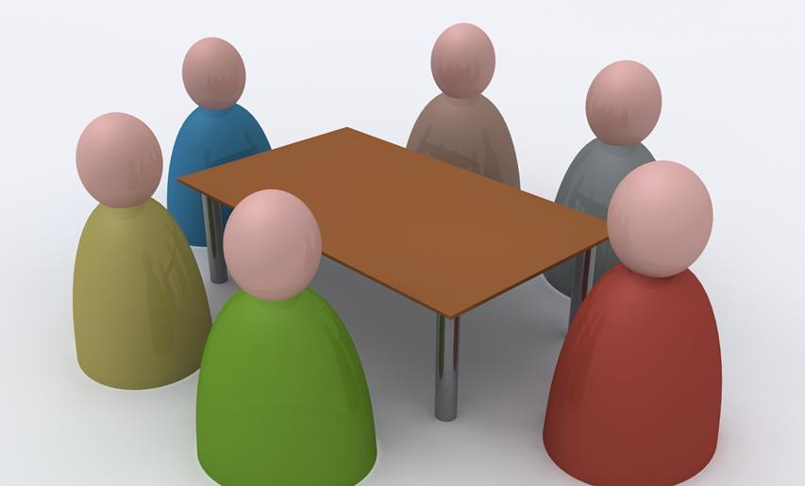  Resident meeting  Watch TVBJ/movie  Games/karaoke  輕柔運動/閱讀報纸  住客開會  看無缐電視/遊戲/卡拉ok | Gentle exercise 4  Newspaper reading  Watch TVBJ/movie  Game/karaoke  輕柔運動  閱讀報纸  看無缐電視  遊戲/卡拉ok
Gentle exercise 5  Newspaper reading  Watch TVBJ /movie/Games  輕柔運動  閱讀報纸  看無缐電視/遊戲 | Gentle exercise 6  Newspaper reading    Jimmy Giang, Kwok Ki Tsoi,  Shuk Wan Lee & Elaine Feng visit  Watch TVBJ/movie/Bible reading  Games/Karaoke  輕柔運動/ 閱讀報纸  江志華,蔡國基,李淑雲,  馮玉玲到訪    看無缐電視/查經  遊戲/卡拉ok | Gentle exercise 7  Newspaper reading  Buddhist chanting  Watch TVBJ/movie  Games/karaoke  輕柔運動  閱讀報纸  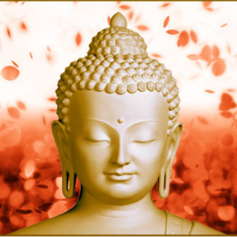  誦經  看無缐電視  遊戲/卡拉ok | Gentle exercise 8  Newspaper reading  Haircut  Watch TVBJ/movie  Game/karaoke    輕柔運動,  閱讀報纸  剪頭髮  看無缐電視  遊戲/卡拉ok | Gentle exercise 9  Newspaper reading  Watch TVBJ/movie  Library round ,One to one chat  輕柔運動  閱讀報纸  看無缐電視  借閱書籍,閒談 | Gentle exercise 10  Newspaper reading  Health talk – fall prevention  TVBJ/movie  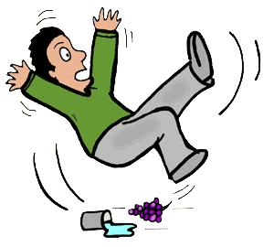  Games/karaoke  輕柔運動  閱讀報纸  健康講座-訪止摔倒  看無缐電視  遊戲/卡拉ok | Gentle exercise 11  Newspaper reading  Campbeltown Christian group visit  Watch TVBJ/movie  Game/karaoke  輕柔運動    閱讀報纸  金寶鎮教會到訪  看無缐電視  遊戲/卡拉ok
Gentle exercise 12  Newspaper reading  Watch TVBJ /movie  Games/Karaoke  輕柔運動  閱讀報纸  看無缐電視/遊戲/卡拉ok | Gentle exercise 13  Newspaper reading  Birthday Celebration  Chinese Opera singing group visit  Watch TVBJ /movie/Bible reading  輕柔運動/閱讀報纸    生日會  雪梨華藝粵軒社到訪  看無缐電視/查經 | Gentle exercise 14  Newspaper reading  Watch TVBJ /movie  Games/karaoke  輕柔運動  閱讀報纸  看無缐電視  遊戲/卡拉ok | Gentle exercise 15  Newspaper reading  Feather friends visit    Games  karaoke  輕柔運動/閱讀報纸  依人小鳥到訪  遊戲  卡拉ok | Gentle exercise 16  Newspaper reading  Watch TVBJ /movie  Game/karaoke  Library round, one to one chat  輕柔運動  閱讀報纸  看無缐電視  遊戲/卡拉ok/借閱書籍,閒談 | Gentle exercise 17  Newspaper reading  Elizabeth Tse ,& Amy Ko visit  Watch TVBJ /movie  Game/karaoke  輕柔運動/讀報纸  鄭幗晶,高淑蘭到訪  看無缐電視  遊戲/卡拉ok | Gentle exercise 18  Newspaper reading  Beverlly Hills church visit    Watch TVBJ /Movie  Game/karaoke  輕柔運動/閱讀報纸  比華利山教會到訪  看無缐電視  遊戲/卡拉ok
Gentle exercise 19  Newspaper reading  Watch TVBJ/movie  Games/Karaoke  輕柔運動  閱讀報纸  看無缐電視  遊戲/卡拉ok | Gentle exercise 20  Newspaper reading  Community singing group visit  Games/karaoke/Bible reading  輕柔運動  閱讀報纸    粵韻天聲到訪  遊戲/卡拉ok/查經 | Gentle exercise 21  Newspaper reading  Watch TVBJ/movie  Games/karaoke  輕柔運動  閱讀報纸  看無缐電視  遊戲/卡拉ok | Gentle exercise 22  Newspaper reading  Community singing group visit  Watch TVBJ/Game/karaoke  輕柔運動/閱讀報纸  看無缐電視    友誼閒敍到訪  遊戲/卡拉ok | Gentle exercise 23  Newspaper reading  Watch TVBJ/movie  Game/karaoke  柔運動  閱讀報纸  看無缐電視  遊戲/卡拉ok | Gentle exercise 24  Newspaper reading  Watch TVBJ/movie  Game/karaoke  輕柔運動,閱讀報纸  粵韻天聲到訪  看無缐電視/ 遊戲/卡拉ok | Gentle exercise 25  Newspaper reading  Watch TVBJ/movie  Game/karaoke  輕柔運動  閱讀報纸  看無缐電視/遊戲/卡拉ok
Gentle exercise 26  Newspaper reading  Watch TVBJ/movie  Games/karaoke  輕柔運動  閱讀報纸  看無缐電視  電影/卡拉ok | Gentle exercise 27  Newspaper reading  Watch TVBJ/movie  Games/karaoke  輕柔運動,閱讀報纸  看無缐電視  遊戲/卡拉ok | Gentle exercise 28  Newspaper reading  Watch TVBJ/movie  Games/karaoke  輕柔運動  閱讀報纸  看無缐電視  遊戲/卡拉ok | Gentle exercise 29  Newspaper reading  Watch TVBJ/Game/karaoke  輕柔運動  閱讀報纸  看無缐電視  遊戲/卡拉ok | Gentle exercise 30  Newspaper reading  Watch TVBJ/movie  Game/karaoke  柔運動  閱讀報纸  看無缐電視  遊戲/卡拉ok | Gentle exercise 31    Newspaper reading  Outing  Watch TVBJ/movie  Game/karaoke  輕柔運動,閱讀報纸  戶外活動  粵韻天聲到訪  看無缐電視/ 遊戲/卡拉ok | 《塞下曲》  【唐】盧綸  月黑雁飛高，  單于夜遁逃。  欲將輕騎逐，  大雪滿弓刀。

