
Key Feature Statement
Tully Nursing Home Inc.

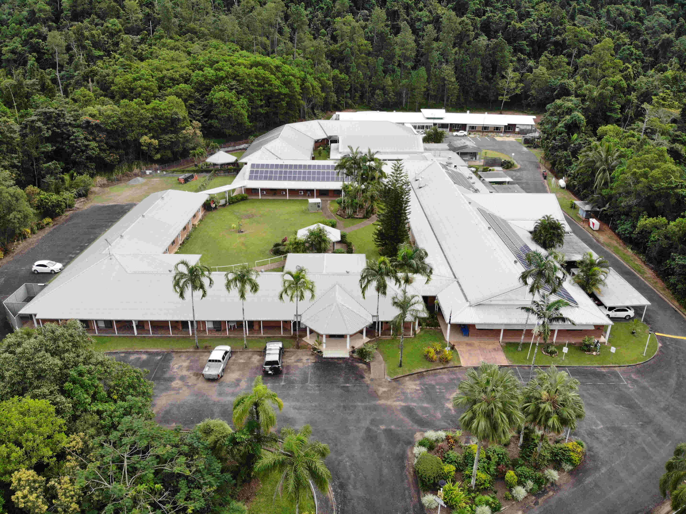



Overview
Tully Nursing Home is a community owned not-for-profit Aged Care facility. We can offer Permanent Residential Care and Residential Respite Care within a caring homelike environment and uphold a strong focus on providing quality, compassionate and meaningful care services by experienced and friendly staff.

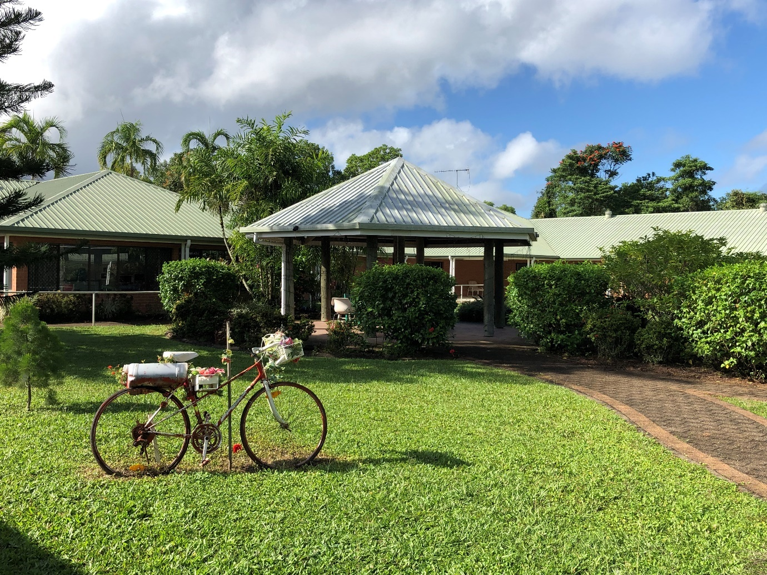

Our facility offers 72 single rooms all of which have private ensuite bathrooms.
All residents have access to 24 hour emergency call systems and staff are on duty at all times to provide care and assistance.

The Rooms
Pine Lodge – 11 bed unit

Large air-conditioned single rooms (33.38m2) with private ensuite and patio.
Each room has a kitchenette, lounge/dining spaces. The rooms provide in-room storage, including walk-in wardrobe with shelving and chest of drawers with one lockable. Every room has telephone and television connections and safety systems installed e.g. nurse call and fire safety services.
The current refundable accommodation deposit for these rooms is $450,000, providing an equivalent daily accommodation payment of $49.81/day.

Flametree Wattle – 21 bed unit

Standard air-conditioned single rooms (18.16m2) with private ensuite.
The rooms provide in-room storage, including built-in cupboard with shelving and chest of drawers with one draw lockable. Every room has television connections and safety systems installed e.g. nurse call and fire safety services and smoke alarm.
The current refundable accommodation deposit for these rooms is $375,000, providing an equivalent daily accommodation payment of $41.51/day.

Mountain View – 20 bed secure unit built in 2019 divided into 2x10 bed wings

Standard air-conditioned single rooms (18.16m2) with private ensuite.
The rooms provide in-room storage, including built-in cupboard with shelving and chest of drawers with one draw lockable. Every room has television connections and safety systems installed e.g. nurse call and fire safety services, smoke alarm and fire sprinklers.
The current refundable accommodation deposit for these rooms is $375,000, providing an equivalent daily accommodation payment of $41.51/day.

Rainforest – 20 bed unit recently renovated and reopened 2020

Standard air-conditioned single rooms (18.16m2) with private ensuite.
The rooms provide in-room storage, including built-in cupboard with shelving and chest of drawers with one draw lockable. Every room has television connections and safety systems installed e.g. nurse call and fire safety services, smoke alarm and fire sprinklers.
The current refundable accommodation deposit for these rooms is $375,000, providing an equivalent daily accommodation payment of $41.51/day.

Common Areas
Our facility has an array of different common areas to enrich the daily lives of our residents. These areas provide places of tranquility and relaxation as well as places of stimulation and activity. Our aim is to offer variety to our residents’ and harmonious spaces where they can relax alone or interact with each other, family members and our carers.
All common areas are cosy, homelike and comfortable with a tasteful décor. Residents are encouraged to join in the activities or they can simply sit in our comfortable arm chairs to talk, read or watch the large flat screen TV, or they can relax on the outdoor patios or gazebos enjoying the gardens, sunlight, vibrant birdlife and the lush rainforest that surrounds the facility. Our common areas are all wheelchair accessible and include age appropriate furniture and fittings.
Common Area | Size (m2) | Description
Activities Room | 236 | Sliding doors fitted  with cyclone shutters  Hosts group functions  Homely atmosphere  Full kitchen  Seated Tai Chi classes  Focused and personalized activities to residents’  needs and interests  Flatscreen smart TV  Regular services from several denominations
Sitting Room | 34 | Large windows  Plenty of natural light  Relaxing atmosphere  Comfortable lounges  Reading  Suitable for craft and small gatherings
Lounge Rooms x 5 | 230 | Large windows  Flatscreen smart TV  Comfortable lounges
Dining Rooms x 6 | 280 | Sliding doors  Pleasant décor  Clover tables that assist residents to sit comfortably  Tables in groups of 4 and 6
Hairdressing Room | 13 | Hairdressing services
Barbecue Areas x 3  Gazebos x 2  Tiled Verandah’s/Patios x 4 | 701 | Alfresco dining weather permitting  Gardens are landscaped and lush all year round  BBQ  Sunlight  Outdoor furniture  Comfortable outdoor chairs
Fees
Daily Care Fee (DCF)
Covers meals, cleaning and laundry
For fully subsidised residents nursing care and accommodation is also included
Payable by all residents and is equivalent to 85% of the basic aged pension

Means Tested Fee (MTF)
If applicable, covers cost of nursing care
The following caps apply:

Annual Cap - $28,338.71
Department of Human Services (DHS) may instruct a daily MTF. Once the cap is reached no more MTF can be charged until the next anniversary of commencing care
Lifetime Cap - $68,012.98
Once the lifetime cap is reached no more MTF can be charged

Refundable Accommodation Deposit (RAD) or Refundable Accommodation Contribution (RAC)
If applicable, covers the cost of the room
Means tested by Department of Human Services (DHS) through assessment of Combined Income & Assets form SA457 or SA485. RAD’s and RAC’s are fully refundable on the resident’s passing or transfer to another facility.

You may choose to pay a daily payment know as:
a Daily Accommodation Payment (DAP) or a Daily Accommodation Contribution (DAC) DAP & DAC are not refundable.
Calculation = Room Price x 4.04% Maximum Interest Rate Permissible ÷ 365 days = daily accommodation amount

MyAged Care Fee Estimator
To get an estimate of the fees you may have to pay when entering into an aged care home, you can access the My Aged Care Residential Fee Estimator at: http://www.myagedcare.gov.au/fee-estimator/resisential-care/form
Tully Nursing Home Policy
An Interim MTF (Means Tested Fee) and the DAP (Daily Accommodation Payment) will be applied from the entry date until Tully Nursing Home Inc. receives advice from the Department of Human Services (DHS) outlining the charges to be applied. Upon receipt of this advice any non-applicable charges previously billed will be debited or credited to the Care Recipient’s account The Interim MTF daily rate is currently $77.64 ($28,338.71 Annual Cap ÷ 365 days)

Example Payment for Room Price of $375,000
Current Residential Care Fees will be applied until Tully Nursing Home receives:
- Option decision from the care recipient/or their representative
- Assessment letter addressed to Tully Nursing Home from Department of Human Services
$ 52.71 - per day Daily Care Fee (DCF)
$ 77.64 - per day Interim Means Tested Fee (MTF)
$ 41.51 - per day Daily Accommodation Payment (DAP)
$171.86 Daily Fees

Accommodation Payment Options

There are four options to pay for your accommodation, you have 28 days from date of entry to decide on an option and 6 months to pay. Until the nursing home receives the RAD/RAC the DAP/DAC will be applied.

Option 1 - Pay RAD in Full Example: $375,000

A Refundable Accommodation Deposit (RAD) is fully refundable on the resident’s passing or transfer

Residential Care Fees until assessment is received:
$ 52.71 - per day Daily Care Fee (DCF)
$ 77.64 - per day Interim Means Tested Fee (MTF)
$130.35 Daily Fees

Option 2 - Pay a Daily Payment
A Daily Accommodation Payment (DAP) is the daily payment for the room.
This option is sometimes used if there is an un-protected house to be sold and the care recipient has funds in the bank to cover this fee until a settlement of sale occurs.

Calculation for DAP
$375,000 Room Price x 4.04% Maximum Interest Rate Permissible ÷ 365 days = $41.51 per day

Residential Care Fees until assessment is received:
$ 52.71 - per day Daily Care Fee (DCF)
$ 77.64 - per day Interim Means Tested Fee (MTF)
$ 41.51 - per day Daily Accommodation Payment (DAP)
$171.86 Daily Fees

Option 3 - Pay a Combination of a RAD & DAP
You may choose to pay a combination of a RAD and a DAP
Example: Pay a Refundable Accommodation Deposit (RAD) + Balance of room price as a Daily Accommodation Payment (DAP)
$225,000.00 - RAD
$ 16.60 - DAP - Calculation =
$150,000 (balance of room price) x 4.04% ÷ 365 = $16.60/day

Residential Care Fees until assessment is received:
$ 52.71 - per day Daily Care Fee (DCF)
$ 77.64 - per day Interim Means Tested Fee (MTF)
$ 16.60 - per day Daily Accommodation Payment (DAP)
$146.95 Daily Fees

Option 4 – Drawdown

You may choose to pay a lump sum and drawdown to pay for all or some of your fees. Any residual amount remaining on the residents’ passing or transfer is refundable.
*Please note that if you choose this option as you will be drawing down from the lump sum the DAP will increase as the facility no longer holds the full lump sum amount. *

Example - Pay RAD of $225,000 + DAP of $16.60 (Daily Payment for Remaining Room Price Balance)

$225,000.00 – Lump Sum RAD/RAC
-$ 52.71 - Daily Care Fee (Revised by the Department of Human Services quarterly)
-$ 16.60 - DAP
-$ 77.64 - Interim MTF (Revised by the Department of Human Services as required)
Any residual amount remaining on the resident passing or transfer is refundable

Extra Services

Hairdressing
- Frequency - as per monthly timetable
- Cost – Haircut only $18.00 for Men or $30.00 for Women (subject to change e.g. annual price increase or extra service requested

Tag & Testing all electrical equipment brought into the facility
- Frequency – on entry and then annually
- Cost - $5.00 per item

Shopping (Online or local)
- Frequency – on request
- Cost – at cost

Services

Facility Manager
Business Manager
Clinical Nurse
Clinical Staff (Including RN’s and EN’s) 24/7
Care Staff 24/7
Leisure and Lifestyle Staff
Catering Staff
Hotel Services (Including Laundry and Cleaning)
Maintenance
Pastoral Care

Scheduled Visits by Care Professionals

General Medical Practitioner
Speech Pathologist/Therapist
Podiatrist
Psychologist
Physiotherapist
Continence Adviser
Other Allied Health as Required
Hairdresser

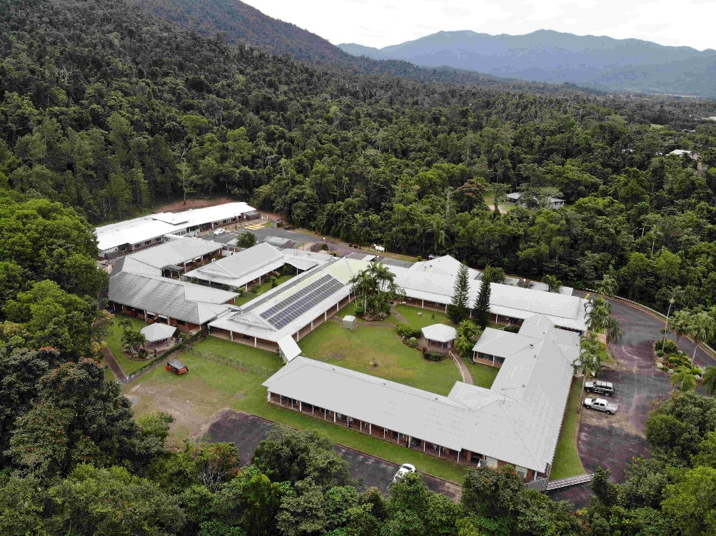

Contact
For more enquiries
please call 07 4068 2355
or
email bm@pinehaven.com.au

13 Bryant Street

Tully Nursing Home Inc.
13 Bryant Street,
Tully Qld 4854

Postal:
PO Box 867,
Tully Qld 4854

www.tullynursinghome.com.au


 Tully Nursing Home Inc.

